Karthik Pradeep Hegadi­­­­

**2KE20CS032­­­**

**Assignment 7**

*Understood. To follow the provided instructions and create the files/directory using the same name and case as provided in the task steps, please provide me with the specific names and case instructions for the files/directory you want to create.*

**CoE Systemctl Assignment**

1.Create a simple script(logtime.sh)under /usr/local/bin/



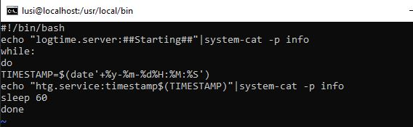

1.Make that file executable.(set permissions)



2.Create a service definition file(mytimelog.service) at /etc/systemd/ system to start this program by systemd. This is called a unit file for the new service.



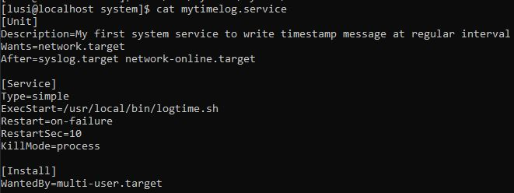

1.set the permissions to this file to give the owner read and write permissions, read permissions to the group. Others will have no permissions.

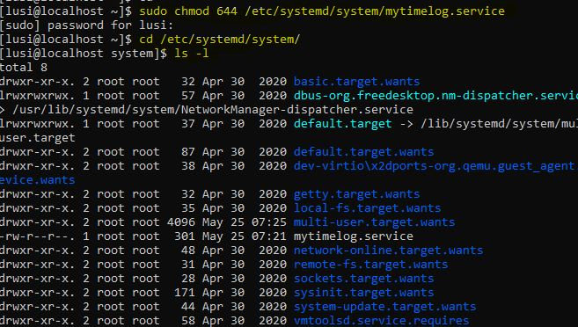



2.use systemctl command to reload the unit file definitions.



3.use systemctl command to enable service to be launched at startup.



4.use systemctl command to start the service.



5.use systemctl command to verify if the service is running correctly

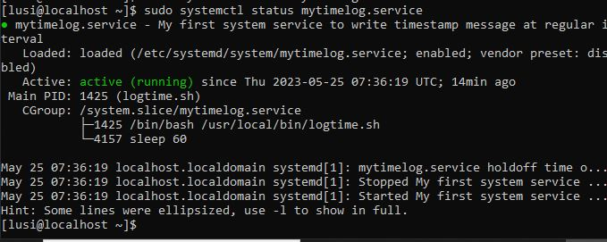

6.use systemctl command to stop the service

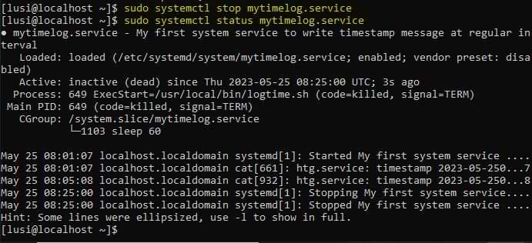

7.Reboot the system and check the status of the service using systemctl commnd and Note: You should not start the service explicitly. It should have been started during boot­­­­­­­­

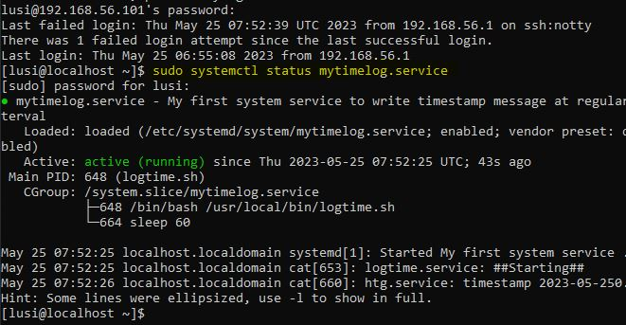

8.Disable the service using systemctl command. This should prevent It from launching at startup.

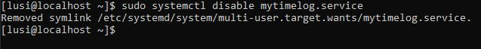

9.Reboot the system and check the status of the service using systemctl command.You should see an error.

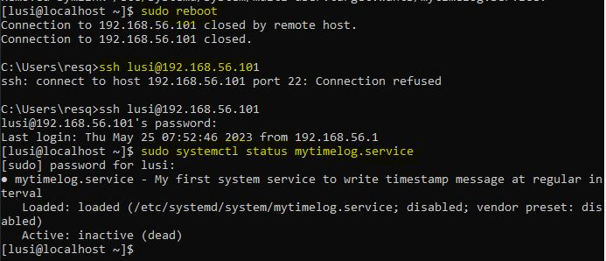

10.Enable the service using systemctl command

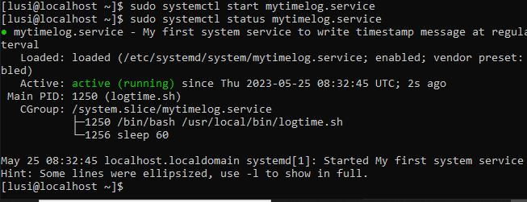

11.Reboot the system and check the status of the service using systemctl command Note:You should see the running status of the service.

